**Test Document for Super Procure Fuctionality**

Insert Data in table tdisg140 from backend for testing.

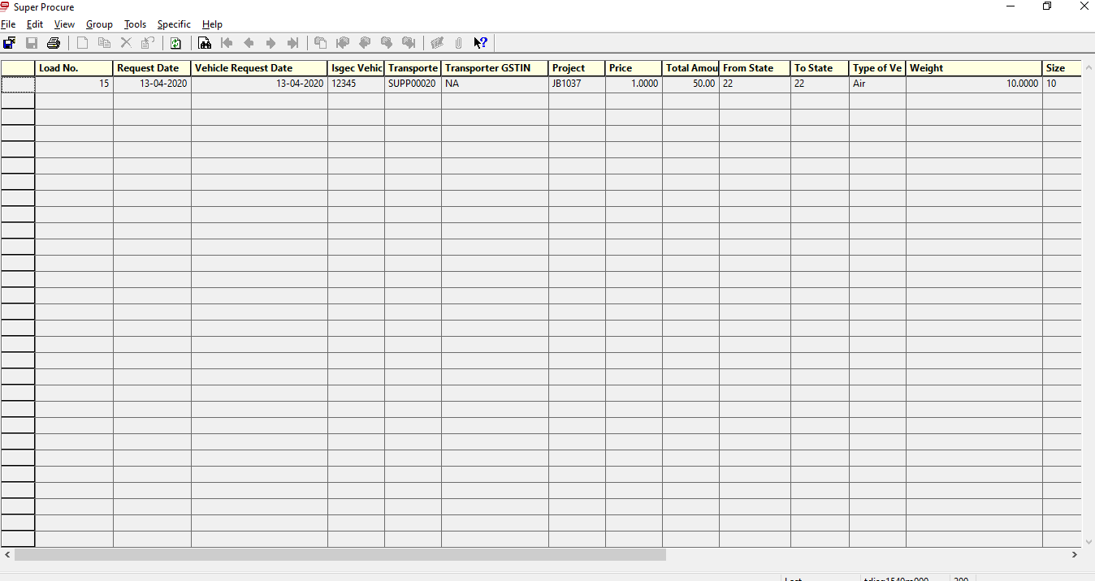

Test for Load no 15

Click Button Generate Purchase Order from Specific Button in menu.

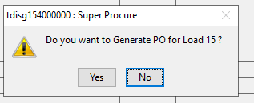

After “Yes” its created PO P60105129.

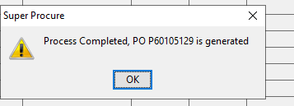

Output:

PO P60105129 is created, Please show the Screetshot

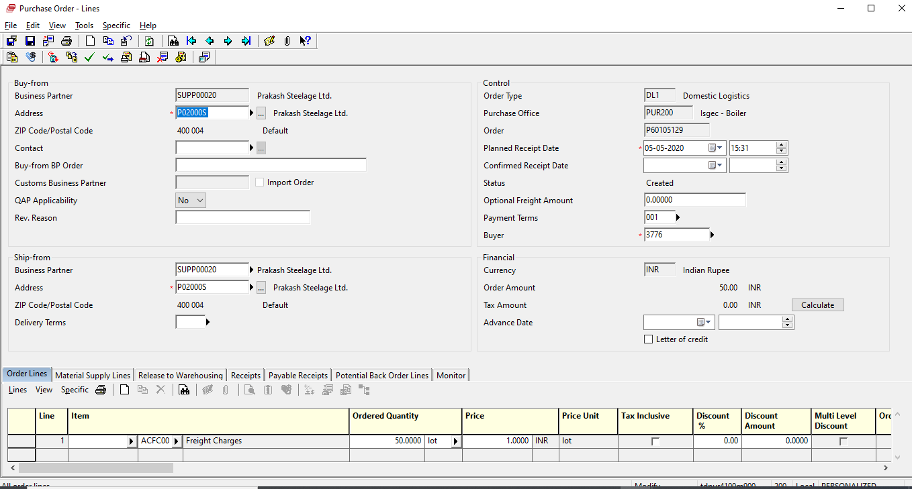

Payment Term:

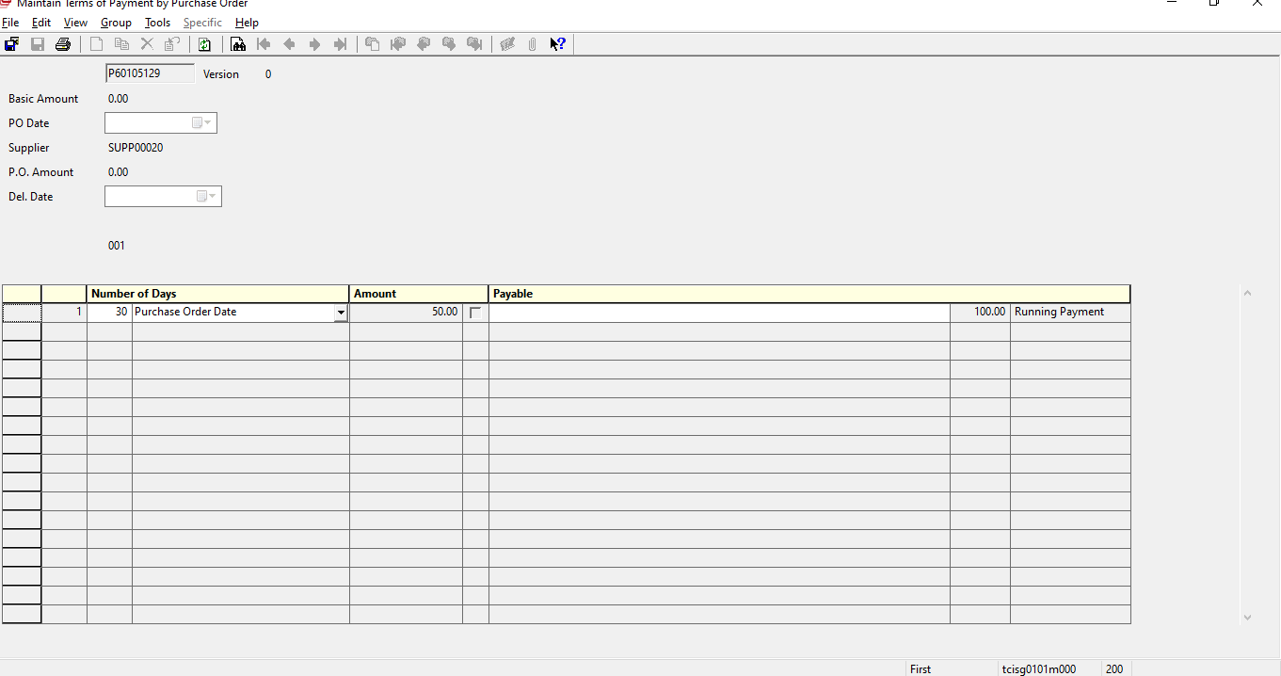

Maintain Document Required.

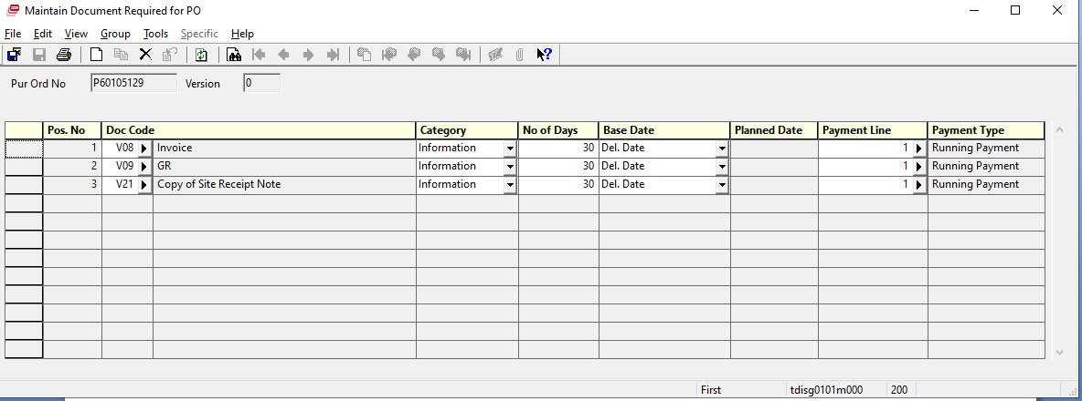

In Line text

